Given the root of a binary tree, return *the length of the longest* ***consecutive sequence path***.

A **consecutive sequence path** is a path where the values **increase by one** along the path.

Note that the path can start **at any node** in the tree, and you cannot go from a node to its parent in the path.

**Example 1:**

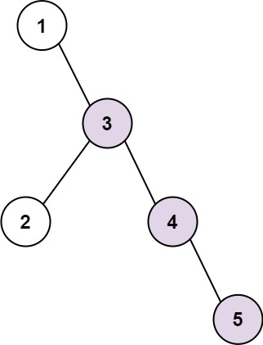

Input: root = [1,null,3,2,4,null,null,null,5]  
Output: 3  
Explanation: Longest consecutive sequence path is 3-4-5, so return 3.

**Example 2:**

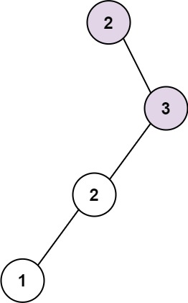

Input: root = [2,null,3,2,null,1]  
Output: 2  
Explanation: Longest consecutive sequence path is 2-3, not 3-2-1, so return 2.

**Constraints:**

* The number of nodes in the tree is in the range [1, 3 * 104].
* -3 * 104 <= Node.val <= 3 * 104